TASK 03 – DATA ANALYSIS REPORT

1. INTRODUCTION
In this task, I analyzed the CoreTech business dataset created in Task 2 using Excel/Google Sheets formulas. The purpose of this task was to perform data analysis and extract useful business insights such as budget analysis, project status, revenue calculation, and client distribution.

2. DATASET DESCRIPTION
The dataset contains 50 records of clients with the following fields:
- Client_ID
- Client_Name
- Company_Name
- Service
- Project_Budget
- Project_Status
- Start_Date
- End_Date
- Client_City
- Lead_Source
- Payment_Status
- Client_Rating

3. TOOLS USED
- Google Sheets
- Google Drive
- Microsoft Excel (Formulas Practice)

4. FORMULAS APPLIED
The following formulas were used:
- SUM
- AVERAGE
- MAX
- MIN
- COUNTA
- COUNTIF
- SUMIF
- VLOOKUP
- XLOOKUP

5. KEY RESULTS / ANALYSIS
- Total Budget: 278000
- Average Budget: 5560
- Highest Budget: 10000
- Lowest Budget: 2600
- Total Clients: 50
- Completed Projects: 35
- Pending Projects: 4
- Paid Revenue: 184900
- Average Rating: 4.5

Lead Source Distribution:
- Website Clients: 14
- LinkedIn Clients: 13
- Referral Clients: 12
- Facebook Clients: 11

Lookup Results:
- VLOOKUP Example: Bilal Ahmed
- XLOOKUP Example: Zain Ali

6. INSIGHTS
- Most projects were successfully completed, showing strong performance.
- Paid revenue is high, indicating good financial performance.
- Website and LinkedIn are major sources of client acquisition.
- Client satisfaction is strong with an average rating of 4.5.

7. SCREENSHOTS
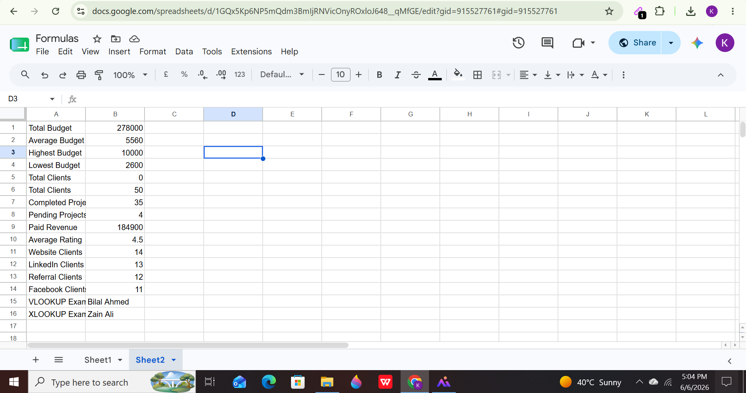

8. DATASET LINK
https://docs.google.com/spreadsheets/d/1GQx5Kp6NP5mQdm3BmIjRNVicOnyROxloJ648__qMfGE/edit?usp=sharing

9. CONCLUSION
This task helped me understand how Excel/Google Sheets formulas are used for real world data analysis. It improved my ability to analyze business data, generate insights, and present structured reports.

